Siddharth_Bhal_PS1

1. One example is edge detection. If you try to calculate gradients on a noisy image, you will get lots of steep gradients in your image. The way to achieve this is to convolve smoothing filter with gradient filter. This way we can use convolution to efficiently filter an image.

2. Dilation of [0 0 1 1 0 0 1 1] with SE [1 1 1] = [0 1 1 1 1 1 1 1]

3. f' = [0 -1/2 1/2 0]

f'' = [-0.25 0.5 -0.25 0] = f' convolution f'

4.

Non Maximum Suppression can be used to trim wide edges by selecting points with local maximum along gradient direction.

Hysteresis Thresholding can be used to trim light edges by selection appropriate low and high threshold values.

5. One of the possible flaw of using additive Gaussian noise is that we lose detail doing so. Even when we have to remove gaussian noise, we need to use gaussian filter which will smooth the image and as a result image's details are lost.

6. Here main task is to distinguish object from surrounding. Then only we can find any defect in object. To distinguish object from surrounding we need to find edges of object.

Using Canny Edge Detection Algorithm will be useful in this case.

Steps to find edges in image:

1. Smooth Image - Smoothing of image is done to find actual gradient changes in images. This is required especially when there is noise in image as noise will come as steep gradient changes in image. This can be done using Gaussian filter.

2. Gradient filter - Use gradient filter (Sobel) to find intensity gradient of image.

3. Thinning of ridges by Non Maximum suppression. Now all ridges are down to single pixel.

4. Hysteresis Thresholding to complete edges if they are broken by appropriately using high and low threshold.

Now we can use k-cluster machine learning algorithm to make cluster of correct shape objects and whenever variance of current image is greater than some threshold value from out data set, then we can conclude that object is defective.

2.

c.

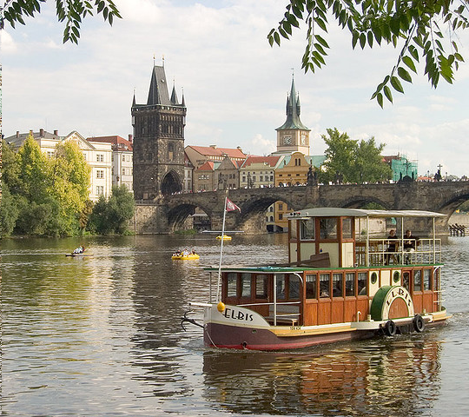

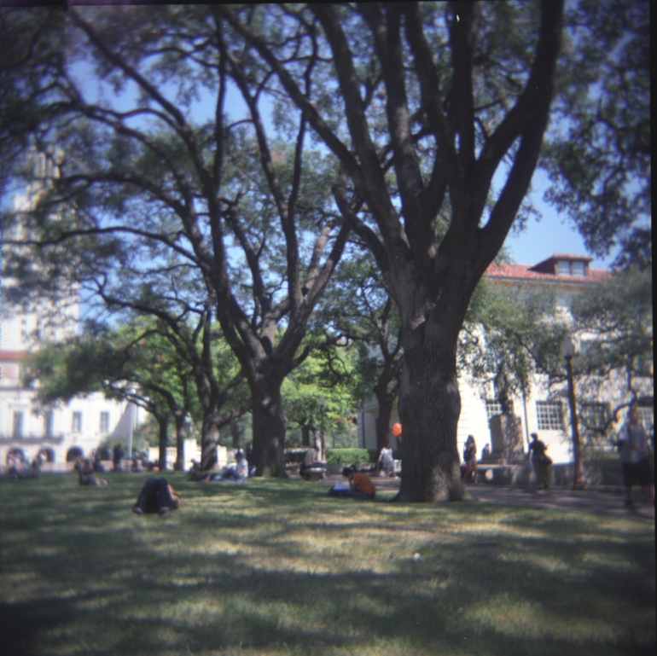

2.

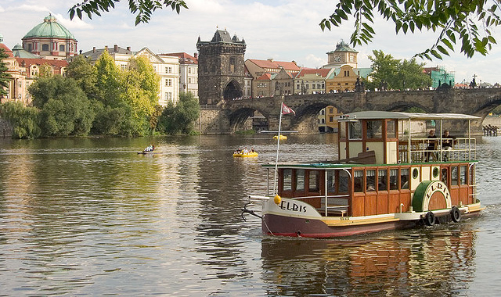

and

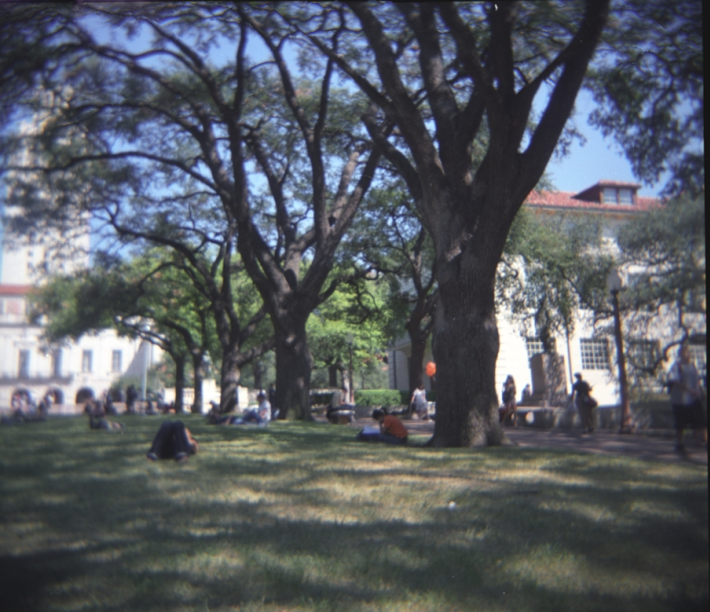

3.

Energy Image

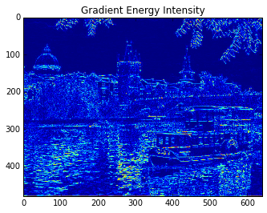

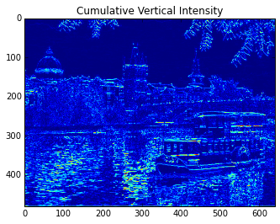

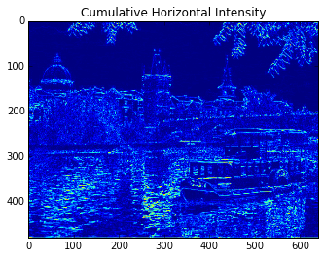4.

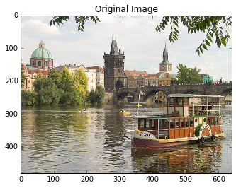Vertical Seam ( on left edge of image)

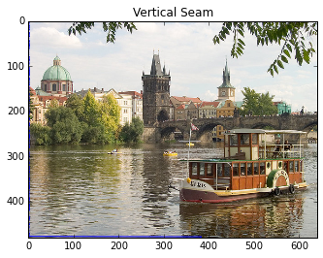Horizontal Seam:

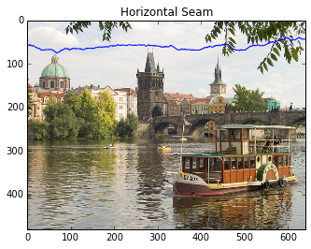5. I am using sobel filter to compute energy function

6.

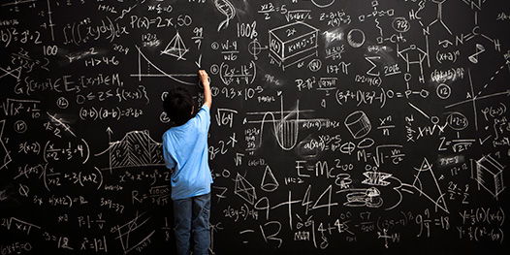Input Image is

Seam Carving Resize image:

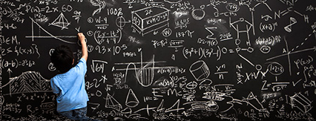

Pyplot resize:

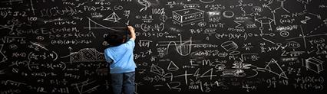

Input Image dimentions: 526x623

Output Image dimentions: 426x123

Since color of jeans of guy standing with image is matching with background, there seam carving algorithm is cropping it out.

Second Image

Original Image is

Seam Carving Resize:

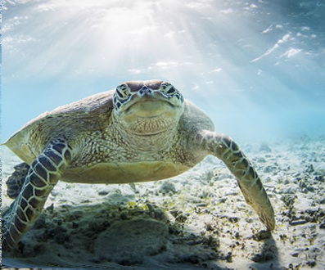

Pyplot resize:



Original Image Size: 497x 430

Resized Image Size: 397x330

Here Head of tortoise is flattened but area aroung the legs of tortoise have very good details in seam carving algorithm. Here Seam Carving algorithm is better fit.

Input Image:

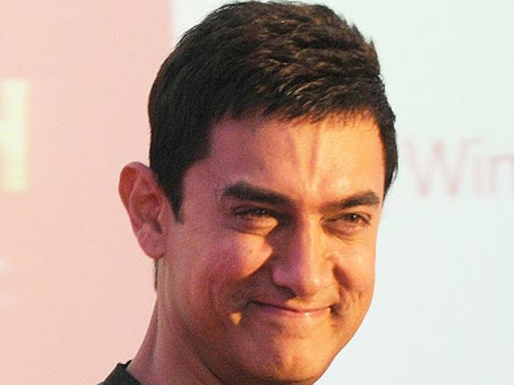

Seam Carving Output Image:

Pyplot output image

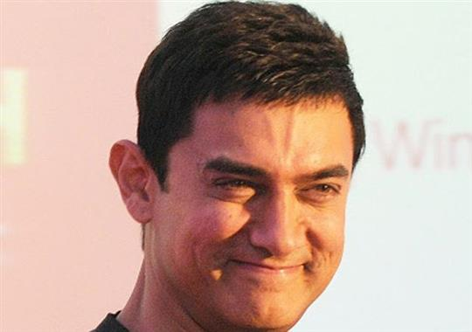

Original Image dimentions:640x480

Resized Image dimentions: 540x380

On human faces, seam carving algorithm is not working well as expected.